+22

**PROFESSIONAL EXPERIENCE**

**October 2022 – Present**

**Programmer Analyst**

**Cognizant Technology Solution**

**Responsibilities:**

* Read the service documentation which received from business team.
* Worked on assign defects and new User Story.
* Debug and fix the code and test and deploy to Test and UAT.
* Worked on Spring Batch Application.

**January 2020 - October 2022** **System Engineer**

**Tata Consultancy Services**

**Responsibilities:**

* Ensure the business requirements and functional specifications.
* Worked on daily assign defects and new Requirements.
* Debug and fix the code as well as analyzing the root cause.
* Create Rest API for different services.
* Worked on Rest API for different services.
* Unit testing report and Technical design documentation.

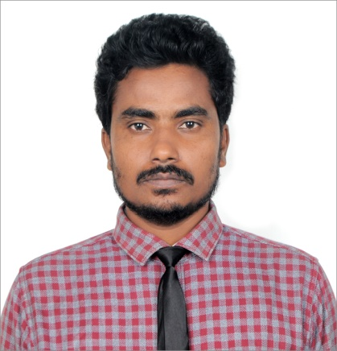

**MD AAMIR HUSSAIN**

SOFTWARE DEVELOPER

4+year of Professional experience in TCS as System Engineer and Programmer Analyst in Cognizant worked on Java, Spring Boot, Microservices.

C:\Users\Kumar_Saurav\Desktop\resume\location000000.png Bangalore

 md.hussain2@cognizant.com

 +91 7260973797

**Birth Date**

05 August, 1994

**Nationality**

Indian

**Languages**

Hindi and English

* Smart Contact Manager
* Online Movie Ticket Booking System.
* Blogging System Using Spring Boot REST API

**PROFILE**

**MD AAMIR HUSSAIN**

**CONTACT**

+++++++++++++++++++++++++++++++++++++++++++++++++++++++++++++++++++++++++++++++

**Education & Qualification**

**B.Tech in Computer Science & Engineering (2014-2018)**

Asansol Engineering College (WBUT)

GPA 7.49

**SKILLS & TECHNOLOGY**

**Core JAVA, JAVA 8, Spring, Spring Boot, Spring Batch, Microservices, REST API, Hibernate and SQL, JavaScript, Shell Script, HTML5, CSS, Angular, AWS**

* Good with programming and logical approach to problem solving.
* Good to follow OOPS and SOLID principles for software structure design.
* Understanding on software development life cycle and agile methodology.
* Framework skills: -Spring Boot.
* Understanding on application testing and unit testing.
* Understanding on Databases and SQLconcept.
* Code debug and bug fixing for improve application performance.
* Understanding of XML and JSON configuration.
* Application Tools and IDE: Microsoft Office, Apache Tomcat Server, Eclipse, MySQL, Control-M, SQL Server, WinSCP.
* Good knowledge of Data Structure and three star in problem solving in Hacker Rank.

P**PERSONAL DETAIL**

**Self-Projects**